**CSS Selectors**

***The Basics: Element, ID and Class***

General rule: *selector {*

*property: value;*

*}*

Example:

HTML

*<!DOCTYPE html>*

*<html>*

*<head>*

*<title> Todo List </title>*

*</head>*

*<body>*

*<h1> Todo List </h1>*

*<ul>*

*<li>*

*<input type= “checkbox”>*

*Walk Rusty*

*</li>*

*<li>*

*<input type= “checkbox”>*

*Buy Groceries*

*</li>*

*<li>*

*<input type= “checkbox”>*

*Finish Recording CSS Videos*

*</li>*

*</ul>*

*</body>*

*</html>*

**Todo List**

* Walk Rusty

* Buy Groceries
* Finish Recording CSS Videos

HTML

*<!DOCTYPE html>*

*<html>*

*<head>*

*<title> Todo List </title>*

*<link rel= “stylesheet” type= “text/css” href= “todos.css”>*

*</head>*

*<body>*

*<h1> Todo List </h1>*

*<ul>*

*<li>*

*<input type= “checkbox”>*

*Walk Rusty*

*</li>*

*<li>*

*<input type= “checkbox”>*

*Buy Groceries*

*</li>*

*<li id= “special”>*

*<input type= “checkbox”>*

*Finish Recording CSS Videos*

*</li>*

*</ul>*

*</body>*

*</html>*

CSS

*li {*

*border: 2px solid red;*

*}*

*#special {*

*background: yellow;*

*}*

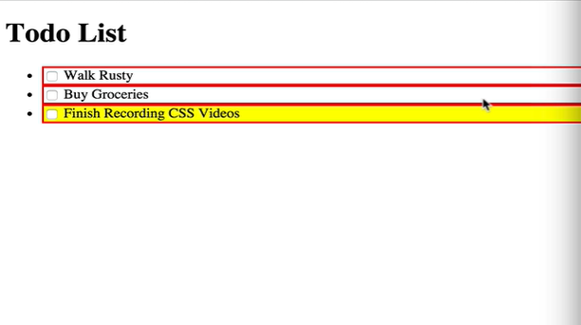

HTML

*<!DOCTYPE html>*

*<html>*

*<head>*

*<title> Todo List </title>*

*<link rel= “stylesheet” type= “text/css” href= “todos.css”>*

*</head>*

*<body>*

*<h1> Todo List </h1>*

*<ul>*

*<li class= “completed”>*

*<input type= “checkbox”>*

*Walk Rusty*

*</li>*

*<li class= “completed”>*

*<input type= “checkbox”>*

*Buy Groceries*

*</li>*

*<li id= “special”>*

*<input type= “checkbox”>*

*Finish Recording CSS Videos*

*</li>*

*</ul>*

*</body>*

*</html>*

CSS

*li {*

*border: 2px solid red;*

*}*

*#special {*

*background: yellow;*

*}*

*.completed {*

*text-decoration: line-through;*

*}*

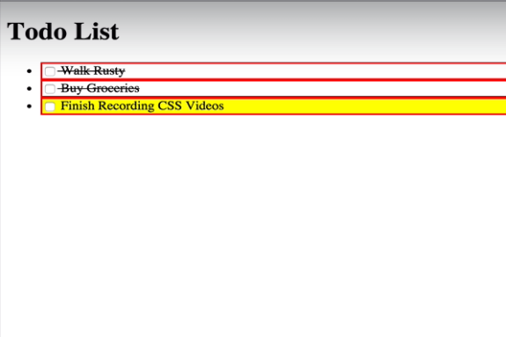

*id -> #*

*class -> .*